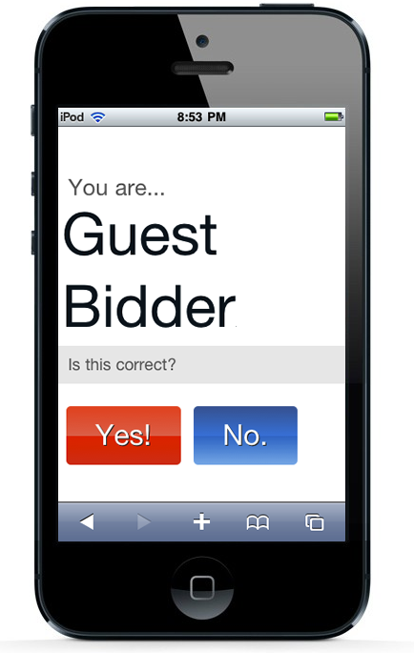
Welcome Screen
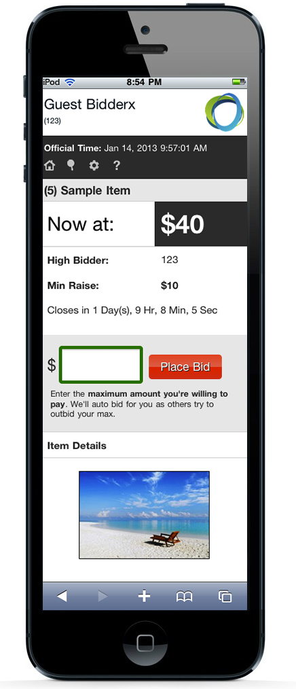
This is the first screen you see when you log in by clicking the link from your email or text message. This screen allows you to confirm your identity before proceeding to the bidding interface.
Item Details

Main Menu
You can enter the item number or search criteria in the red box. An item number lookup takes you directly to the item where can view details. Entering search criteria takes you to a result screen where you can pick your item.
Welcome Screen

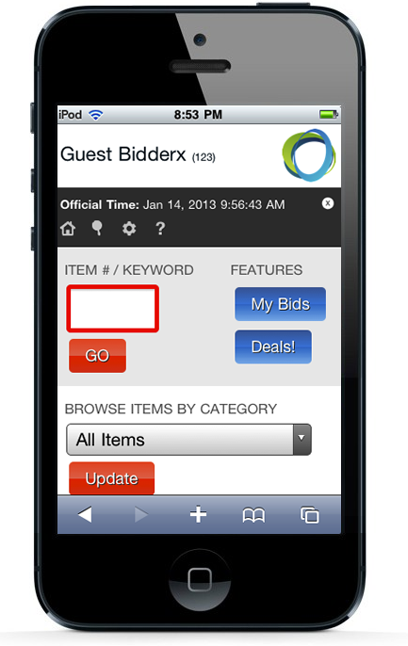
You can view your bidding history and watch list by pressing “My Bids” and you can always see the items with no bids by using the “No Bid Items” button.
Main Menu

You can also filter items by category for a quick look at all the items in a given category.

Item Details
You can see the current bid, the minimum raise, the closing time, a photo and details about the item. You can type the next bid amount or any amount above that and the system will bid for you up to that amount. We’ll send you a text message if you’re outbid! You can also ‘Watch’ the item without placing a bid. We’ll put it on your ‘My Bids’ page so you can keep track of the bidding on that item and jump in when ready!

